NAME:B.Tejaswini
REGNO.:192412684

ECA1803 – OPTOELECTRONICS AND OPTICAL COMMUNICATION
CO5 – CASE STUDY BASED ASSIGNMENT
DWDM Metro Link Commissioning:
From Field Measurements to a Standards-Based Upgrade Decision
Executive Summary
This case study evaluates a 60 km G.652.D metro fiber link carrying eight 10 Gb/s NRZ DWDM channels on a 100 GHz grid. Field data indicate excessive loss at a mechanical splice and a poor connector near the far end, while Channel 5 has a low extinction ratio, high jitter and a partially closed eye. The report calculates the link budget, OTDR limitations, BER/Q performance, quantum detection limits and energy/spectral trade-offs for three 1.6 Tb/s upgrade options.
Recommended action: repair the 1.20 dB reflective connector event first, replace the 0.62 dB mechanical splice with a fusion splice, and retest from both ends using long-pulse and short-pulse OTDR settings as appropriate. Channel 5 must be repaired or replaced because its ER and Q fail the stated acceptance criteria. For the upgrade, Option Q (8 × 200G DP-16QAM) is the balanced recommendation: it reaches 1.6 Tb/s using about 160 W of module power, occupies about 300 GHz under the supplied flex-grid assumptions, and has a calculated OSNR margin of 27.5 dB using the brief's OSNR relation. Option R uses less power but needs 26 dB OSNR and has less OSNR margin.

Case Parameters
Parameter | Given value
Fiber | 60 km, ITU-T G.652.D; attenuation 0.21 dB/km at 1550 nm
Existing WDM | 8 × 10 Gb/s NRZ, 100 GHz grid, +1 dBm/channel at line output
Passive losses | Demultiplexer 6.0 dB; 3 measured connectors at 0.5 dB each; 12 fusion splices at 0.05 dB each; event 2 mechanical splice 0.62 dB; event 3 connector 1.20 dB
Receiver | Sensitivity −24 dBm at BER 10⁻¹² if ER ≥ 8.2 dB; required margin ≥ 3 dB
Amplifier | EDFA NF 5 dB; input −6 dBm/channel; required OSNR 20 dB in 0.1 nm
Performance | Channel 3: Q=7.6, ER=9.0 dB, DJ=0.18 UI, RJ=0.012 UI rms; Channel 5: Q=4.7, ER=4.5 dB, DJ=0.30 UI, RJ=0.022 UI rms
Upgrade target | 1.6 Tb/s on same fiber pair; compare options P, Q and R

Stage 1 – Interpret the Measurement and Performance Requirement (10 Marks)

1.1 Instruments and validated quantities
Instrument | Measurement / use
Optical power meter | Measures launch/received optical power and insertion loss; validates receiver margin.
Optical spectrum analyzer (OSA) | Measures wavelength, channel power, spectral shape, OSNR and channel-to-channel flatness.
OTDR | Locates events by distance and estimates loss/reflectance; dead zones limit closely spaced event analysis.
Eye / BER tester | Eye opening, extinction ratio, deterministic/random jitter, Q-factor and BER; identifies channel-specific degradation.
Dispersion / PMD analyzer | Measures chromatic dispersion and polarization-mode-dispersion characteristics.

Acceptance targets are: receiver power at least −21 dBm if the −24 dBm sensitivity must include 3 dB margin; BER ≤ 10⁻¹²; Q ≥ 7.03; ER ≥ 8.2 dB; OSNR ≥ 20 dB in 0.1 nm for the legacy link; and no unexplained excess-loss events. ITU-T G.652.D defines the single-mode fiber characteristics and ITU-T G.694.1 defines DWDM frequency-grid planning.

1.2 OTDR settings and limitations
The OTDR's event dead zone (EDZ) governs how close a reflective event can be to another event and still be separately identified; attenuation dead zone (ADZ) governs how soon the backscatter trace can be accurately measured after an event. Short pulses improve spatial resolution but reduce dynamic range. The 9 m spacing between events 3 and 4 is resolvable with the 10 ns setting (EDZ 1 m, ADZ 4 m), but that setting has only 20 dB dynamic range. The 100 ns setting has 27 dB dynamic range but a 15 m ADZ, so it cannot reliably separate or measure the second connector 9 m after event 3.
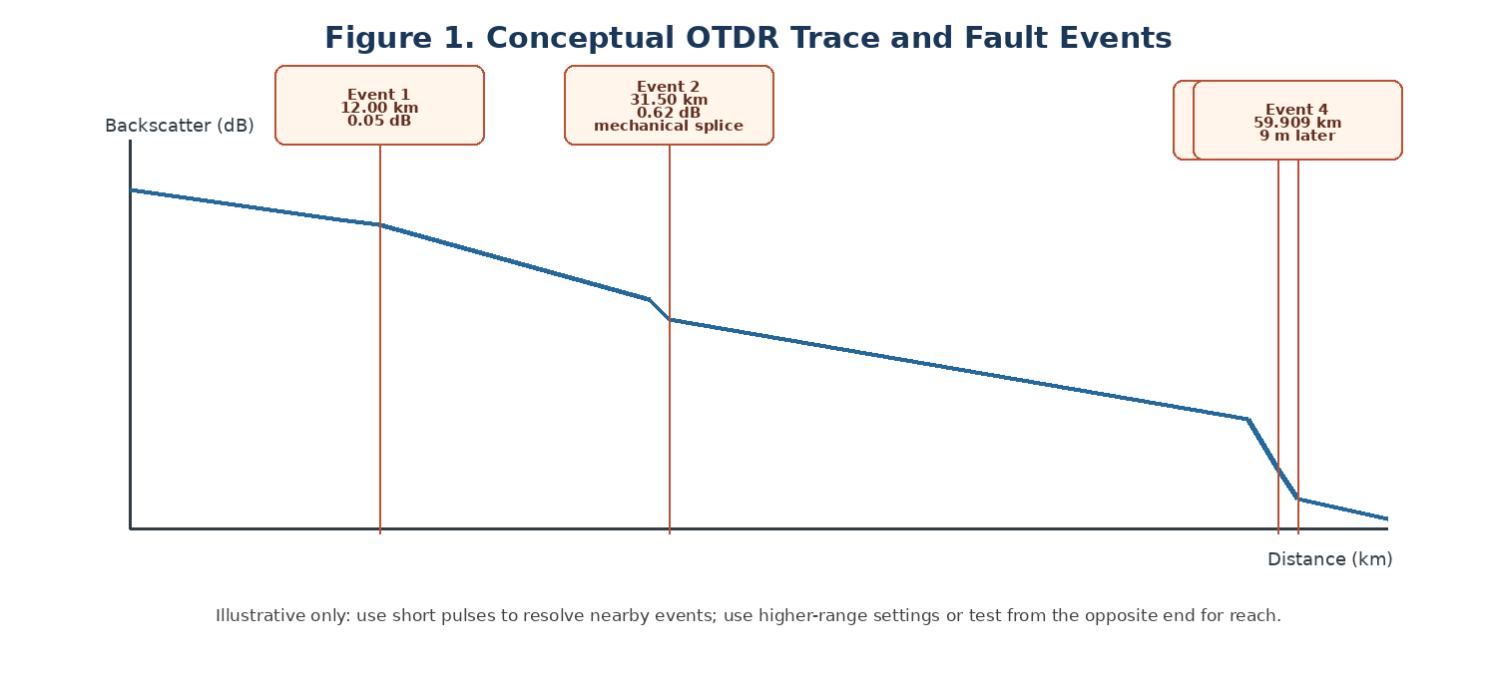
Figure 1. Conceptual OTDR trace showing the supplied event locations; trace is illustrative, not measured data.
Use a higher-dynamic-range, longer-pulse trace from the far end to characterize the complete span, then a short-pulse localized test from the end closest to events 3 and 4. Use bidirectional traces to reduce uncertainty in event-loss interpretation. Spatial distance represented by the OTDR round-trip measurement is approximately cτ/(2n): 10 ns ≈ 1.02 m, 100 ns ≈ 10.21 m, and 1 μs ≈ 102.1 m for n=1.4682.

1.3 Performance requirement statement
Repair the existing 60 km link without replacing the fiber pair; achieve ≤21.25 dB total design loss, received power with ≥3 dB margin, BER ≤10⁻¹² and Q ≥7.03, and meet the OSNR target. Then upgrade to 1.6 Tb/s while meeting the chosen channel-grid, spectral-efficiency, power and interoperability constraints.

Stage 2 – Link Budget, Dispersion and OSNR (20 Marks)

2.1 As-built link loss
Component | Calculation | Loss (dB)
Fiber attenuation | 60 km × 0.21 dB/km | 12.60
Measured connectors | 3 × 0.50 dB | 1.50
Fusion splices | 12 × 0.05 dB | 0.60
Mechanical splice (event 2) | Measured OTDR event | 0.62
Poor connector (event 3) | Measured OTDR event | 1.20
Demultiplexer | Given | 6.00
As-built total | Sum of above | 22.52
Design allowance total | 12.60 + 4×0.5 + 13×0.05 + 6.0 | 21.25
Excess above design | 22.52 − 21.25 | 1.27

The 1.20 dB connector event is the largest individual excess-loss event and should be the first repair priority. The 0.62 dB mechanical splice is also unacceptable compared with a typical fusion-splice allowance of 0.05 dB.

2.2 Received power and penalties
Received power before dispersion/extinction-ratio penalties: P_rx = +1 dBm − 22.52 dB = −21.52 dBm/channel. The raw sensitivity margin is −21.52 − (−24) = 2.48 dB, which is 0.52 dB below the required 3 dB margin even before penalties.
Using the provided dispersion relation δ = 5 log₁₀[1 + 2π(BDLσλ)²], with B=10 Gb/s, D=17 ps/(nm·km), L=60 km and σλ=0.03 nm gives BDLσλ = 0.306 and δ ≈ 3.36 dB. This is a simplified model; actual dispersion penalty depends on transmitter chirp, receiver filtering and the measurement definition.
For the common extinction-ratio penalty approximation, penalty ≈ −10 log₁₀[(ERlinear−1)/(ERlinear+1)]: Channel 3, ER=9 dB (ERlinear≈7.94), penalty ≈1.13 dB; Channel 5, ER=4.5 dB (ERlinear≈2.82), penalty ≈3.28 dB.
Quantity | Channel 3 | Channel 5
Received power before penalties | −21.52 dBm | −21.52 dBm
Dispersion penalty (model) | 3.36 dB | 3.36 dB
ER penalty (approx.) | 1.13 dB | 3.28 dB
Effective power after penalties | −26.01 dBm | −28.16 dBm
Raw margin vs −24 dBm | 2.48 dB | 2.48 dB
Q acceptance (≥7.03) | Pass (7.6) | Fail (4.7)
ER acceptance (≥8.2 dB) | Pass (9.0 dB) | Fail (4.5 dB)

The penalties are quality penalties and should not be interpreted as a literal optical power-meter reading. Channel 3 is only marginal on raw power and has limited remaining penalty budget; Channel 5 is unacceptable due to its poor ER, elevated jitter and low Q. Correct the physical losses and restore Channel 5 transmitter/driver bias or replace the transmitter before increasing launch power.

2.3 OSNR and PMD
Using the relation specified in the brief, OSNR = 58 + P_in − NF = 58 + (−6) − 5 = 47 dB in 0.1 nm. This exceeds the stated 20 dB requirement by 27 dB. Under the supplied model, ASE/OSNR is not the primary legacy-link limitation; excess loss and Channel 5's transmitter/eye quality dominate. This result should be checked against a measured OSA OSNR because the formula is a simplified budget relation.
PMD DGD estimate = PMD coefficient × √L = 0.1 ps/√km × √60 = 0.775 ps. The 10 Gb/s bit period is 100 ps, so 10% is 10 ps. The estimated PMD is well below the tolerance.

Design Decision 1
I recommend repairing the 1.20 dB connector and 0.62 dB mechanical splice before any launch-power increase because the as-built loss is 1.27 dB above the design budget and the raw received-power margin is already below 3 dB. The calculated OSNR is ample under the provided relation, so power/penalties—not ASE noise—are the immediate priority.

Stage 3 – OTDR, Splice and Connector Strategy (20 Marks)
Event | Reading | Interpretation / action
Event 1, 12.00 km | 0.05 dB, non-reflective | Consistent with a low-loss fusion splice; retain and document.
Event 2, 31.50 km | 0.62 dB, reflectance −34 dB | High-loss mechanical splice; replace with fusion splice, then bidirectional OTDR test.
Event 3, 59.900 km | 1.20 dB, reflectance −22 dB | Poor LC/UPC patch-panel connector; inspect/clean first, then replace/remeasure if still high loss.
Event 4, 59.909 km | Reflective, −40 dB; loss unresolved | Second connector 9 m after event 3; use short pulse from near end and power meter to measure combined insertion loss.

Pulse spatial resolution is approximately cτ/(2n): 10 ns ≈ 1.02 m; 100 ns ≈ 10.21 m; 1 μs ≈ 102.1 m. Therefore, the 10 ns pulse can distinguish the two events 9 m apart in principle, but its 20 dB dynamic range is below the approximately one-way fiber-path loss plus 6 dB planning allowance (about 22.5 dB if all supplied path losses are included). The 100 ns setting provides 27 dB range but its 15 m ADZ exceeds the 9 m separation. A two-step test—long pulse for full reach and short pulse from the far end for localized resolution—is appropriate.
Round-trip delay t = 2nL/c. For n=1.4682, the approximate delays are: event 1 at 12.00 km: 117.5 μs; event 2 at 31.50 km: 308.5 μs; event 3 at 59.900 km: 586.9 μs; event 4 at 59.909 km: 587.0 μs. An index error of ±0.002 causes an absolute distance uncertainty of approximately L(0.002/1.4682): ±16 m at 12 km, ±43 m at 31.5 km and ±82 m near 60 km. This is a systematic location uncertainty; the relative 9 m separation is not scaled by the same absolute uncertainty if the same group index is used consistently.
Repair connector event 3/4 first due to its 1.20 dB loss and −22 dB reflectance, then replace event 2 with fusion splice. Clean connector end faces and avoid mating UPC and APC interfaces. LC is appropriate for a compact duplex patch panel; APC can reduce reflections if the complete interface is APC-compatible, but never mate APC and UPC directly. Verify by inspection/cleaning, insertion-loss measurement with a calibrated power meter/light source, and bidirectional OTDR.

Design Decision 2
I recommend a long-pulse, high-dynamic-range OTDR trace for the full 60 km span and a short-pulse localized trace from the far end for the 9 m-spaced connector events. Repair event 3 first and event 2 next; confirm each repair using bidirectional OTDR and end-to-end power-meter loss.

Stage 4 – Eye Diagram, BER and Quantum Limits (20 Marks)

4.1 Q-factor, BER and jitter
BER = 0.5 erfc(Q/√2). Using the supplied Q values, Channel 3 at Q=7.6 has BER approximately 1.5×10⁻¹⁴ (meets 10⁻¹²); Channel 5 at Q=4.7 has BER approximately 1.3×10⁻⁶ (fails by several orders of magnitude). The required Q for BER 10⁻¹² is stated as 7.03.
Total jitter at BER 10⁻¹² is TJ = DJ + 14.07 RJ. Channel 3: TJ = 0.18 + 14.07×0.012 = 0.349 UI, so estimated eye width = 1−TJ = 0.651 UI. Channel 5: TJ = 0.30 + 14.07×0.022 = 0.610 UI, eye width = 0.390 UI. Channel 5 has substantially less horizontal timing margin and a smaller vertical opening due to its low ER/noise.
Measure | Channel 3 | Channel 5 | Acceptance
Q-factor | 7.6 | 4.7 | ≥7.03
Approx. BER | 1.5×10⁻¹⁴ | 1.3×10⁻⁶ | ≤10⁻¹²
ER | 9.0 dB | 4.5 dB | ≥8.2 dB
DJ | 0.18 UI p-p | 0.30 UI p-p | Lower is better
RJ | 0.012 UI rms | 0.022 UI rms | Lower is better
TJ at BER 10⁻¹² | 0.349 UI | 0.610 UI | Lower is better
Eye width estimate | 0.651 UI | 0.390 UI | Larger is better

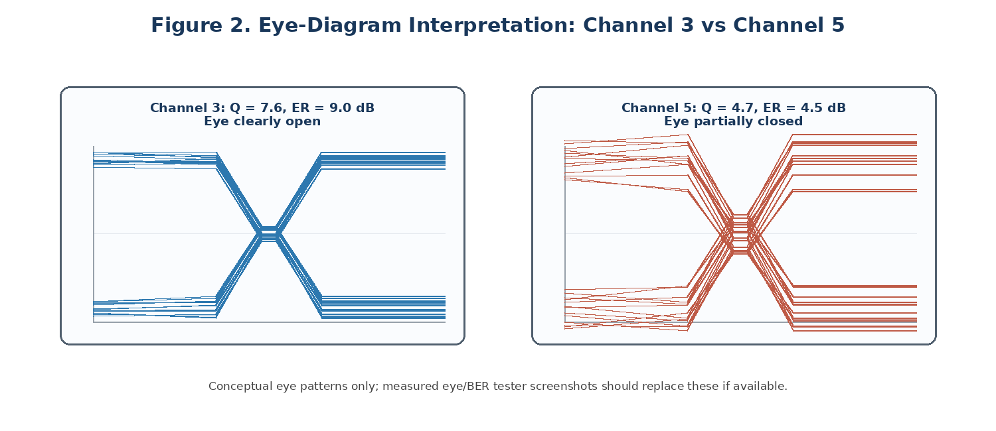
Figure 2. Conceptual eye patterns illustrating a healthy open eye and a degraded partially closed eye;
Because both channels traverse the same fiber but Channel 3 has a healthy eye and Channel 5 has much worse ER and jitter, the evidence points to a channel-specific transmitter/driver, bias, connector path or receiver issue rather than fiber dispersion alone. Measure ER and waveform at the Channel 5 transmitter output and after the receiver; swap transceivers/ports if possible to isolate the cause.

4.2 Photon-counting and coherent detection limits
Photon energy at λ=1550 nm is Eγ=hc/λ≈1.282×10⁻¹⁹ J. For ideal direct detection, BER=0.5 exp(−N₁). Setting BER=10⁻¹² gives N₁=−ln(2×10⁻¹²)≈26.94 photons per ‘1’ bit. At 10 Gb/s this corresponds to P≈N₁EγR≈3.45×10⁻⁸ W = −44.6 dBm. The specified −24 dBm sensitivity is about 20.6 dB above this idealized limit.
For the supplied ideal PSK relations, solve 0.5 erfc(√(2N))=10⁻¹² for homodyne detection and 0.5 erfc(√N)=10⁻¹² for heterodyne detection. This gives approximately N≈12.7 photons/bit for homodyne and N≈25.4 photons/bit for heterodyne. At 10 Gb/s and 1550 nm these correspond to approximately −47.9 dBm and −44.9 dBm, respectively. These are idealized quantum limits, not practical receiver sensitivities; real systems incur implementation, shot-noise, thermal-noise, filtering and coding penalties.

Design Decision 3
I recommend rejecting Channel 5 until ER is restored to at least 8.2 dB, Q rises to at least 7.03 and BER falls to 10⁻¹² or lower. Its low ER and high jitter explain a channel-specific failure more strongly than shared fiber impairment. The measured power margin must also be raised to at least 3 dB through repairs and end-to-end verification.

Stage 5 – Integrated WDM Upgrade and Energy Strategy (20 Marks)

5.1 Grid and occupied spectrum
ITU-T G.694.1 uses a 193.1 THz anchor. For channel n=+3 on a 50 GHz grid, f=193.1 THz + 3×0.05 THz = 193.25 THz. Wavelength λ=c/f≈299,792,458/(193.25×10¹²)=1.5512 μm ≈1551.2 nm.
Option Q uses 32 GBd and roll-off α=0.1, so nominal occupied bandwidth per channel is Rs(1+α)=32×1.1=35.2 GHz. At 12.5 GHz flex-grid slot granularity, the required slot width is ceil(35.2/12.5)=3 slots = 37.5 GHz per channel. Eight channels occupy 8×37.5=300 GHz allocated spectrum.
Option | Channels and format | Allocated spectrum | OSNR target | OSNR margin using 47 dB | Total module power | Energy/bit
P | 16×100G DP-QPSK; 50 GHz slots | 800 GHz | 12.5 dB | 34.5 dB | 352 W | 220 pJ/bit
Q | 8×200G DP-16QAM; 3×12.5 GHz slots each | 300 GHz | 19.5 dB | 27.5 dB | 160 W | 100 pJ/bit
R | 4×400G Si-photonic; 75 GHz slots | 300 GHz | 26 dB | 21 dB | 60 W | 37.5 pJ/bit
Legacy reference | 160×10G SFP+ at 3.5 W | Not directly comparable | 20 dB | 27 dB by simplified formula | 560 W | 350 pJ/bit

Energy per bit is module power divided by aggregate bit rate: P 352/1.6 Tb/s=220 pJ/bit; Q 160/1.6 Tb/s=100 pJ/bit; R 60/1.6 Tb/s=37.5 pJ/bit. The legacy comparison assumes 160 modules to deliver 1.6 Tb/s and excludes line-system overhead. Option R is most energy efficient and spectrally compact but requires 26 dB OSNR; Option Q provides a strong balance between spectrum, module power and OSNR margin while still meeting 1.6 Tb/s.
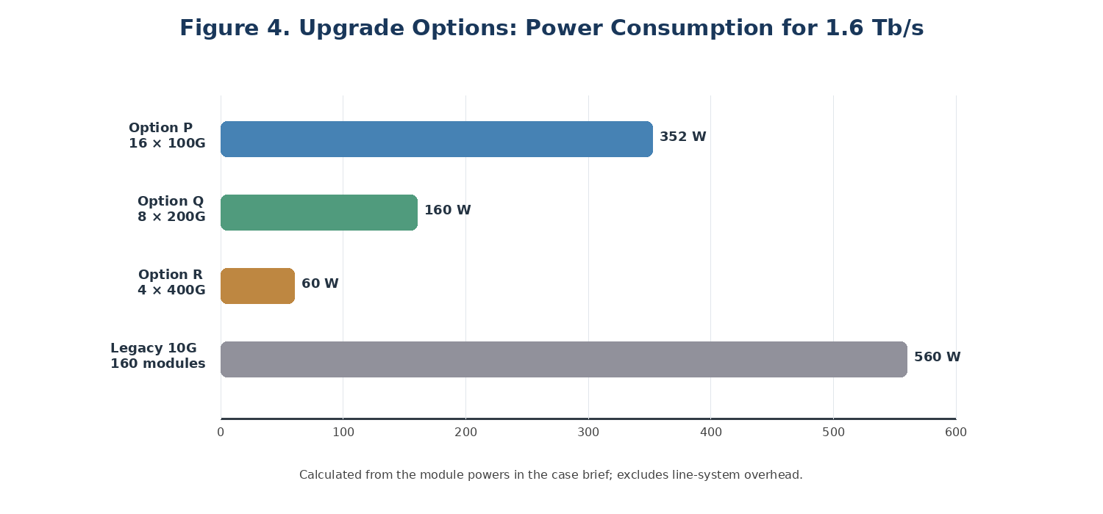
Figure 3. Calculated module power for the three 1.6-Tb/s upgrade options and a 10G SFP+ reference.

5.2 Proposed upgrade sequence
- Repair the 1.20 dB connector and 0.62 dB mechanical splice; clean/inspect all end faces.
- Re-measure insertion loss and OTDR from both directions; confirm total loss and at least 3 dB received-power margin.
- Fix or replace the Channel 5 transceiver/driver and confirm ER ≥8.2 dB, Q ≥7.03 and BER ≤10⁻¹².
- Measure OSNR and channel powers using the OSA; verify grid frequencies and spectral masks for the chosen transceivers.
- Install Option Q as the recommended balanced upgrade candidate; compare Option R if its measured OSNR margin remains adequate with an engineering reserve.
- Repeat end-to-end BER, Q, OSNR, power, eye/constellation, channel-spacing and thermal/power measurements after commissioning.

Design Decision 4
I recommend Option Q (8×200G DP-16QAM) for the balanced deployment baseline. It provides 1.6 Tb/s in 300 GHz allocated spectrum with 160 W module power and 27.5 dB calculated OSNR margin under the provided OSNR relation. Option R is the energy leader at 37.5 pJ/bit but its 26 dB OSNR requirement leaves only 21 dB margin in the simplified model, so choose it only after measured OSNR, FEC performance and operational margin are verified.

Stage 6 – Verification and Final Engineering Decision (10 Marks)
Requirement | Target | Calculated / proposed evidence | Status
Total link loss | ≤21.25 dB | As-built 22.52 dB; repair events 2 and 3 then remeasure | Fail before repair
Received power | ≥−21 dBm for 3 dB margin vs −24 dBm | −21.52 dBm before repair/penalties | Fail by 0.52 dB raw
OSNR legacy | ≥20 dB / 0.1 nm | 47 dB from supplied formula | Pass in simplified model; verify by OSA
PMD | <10 ps | 0.775 ps estimated | Pass
Channel 3 | Q≥7.03, BER≤10⁻¹², ER≥8.2 dB | Q=7.6, BER≈1.5×10⁻¹⁴, ER=9 dB | Pass on stated metrics
Channel 5 | Q≥7.03, BER≤10⁻¹², ER≥8.2 dB | Q=4.7, BER≈1.3×10⁻⁶, ER=4.5 dB | Fail
Upgrade capacity | 1.6 Tb/s | Options P/Q/R each total 1.6 Tb/s | Capacity feasible
Upgrade energy | Minimize pJ/bit | P=220; Q=100; R=37.5 pJ/bit | R best energy; Q balanced
Spectrum | Use efficient grid | P=800 GHz; Q≈300 GHz; R=300 GHz | Q/R more efficient
Deployment | All criteria verified | Repair, test and then deploy Option Q candidate | Conditional

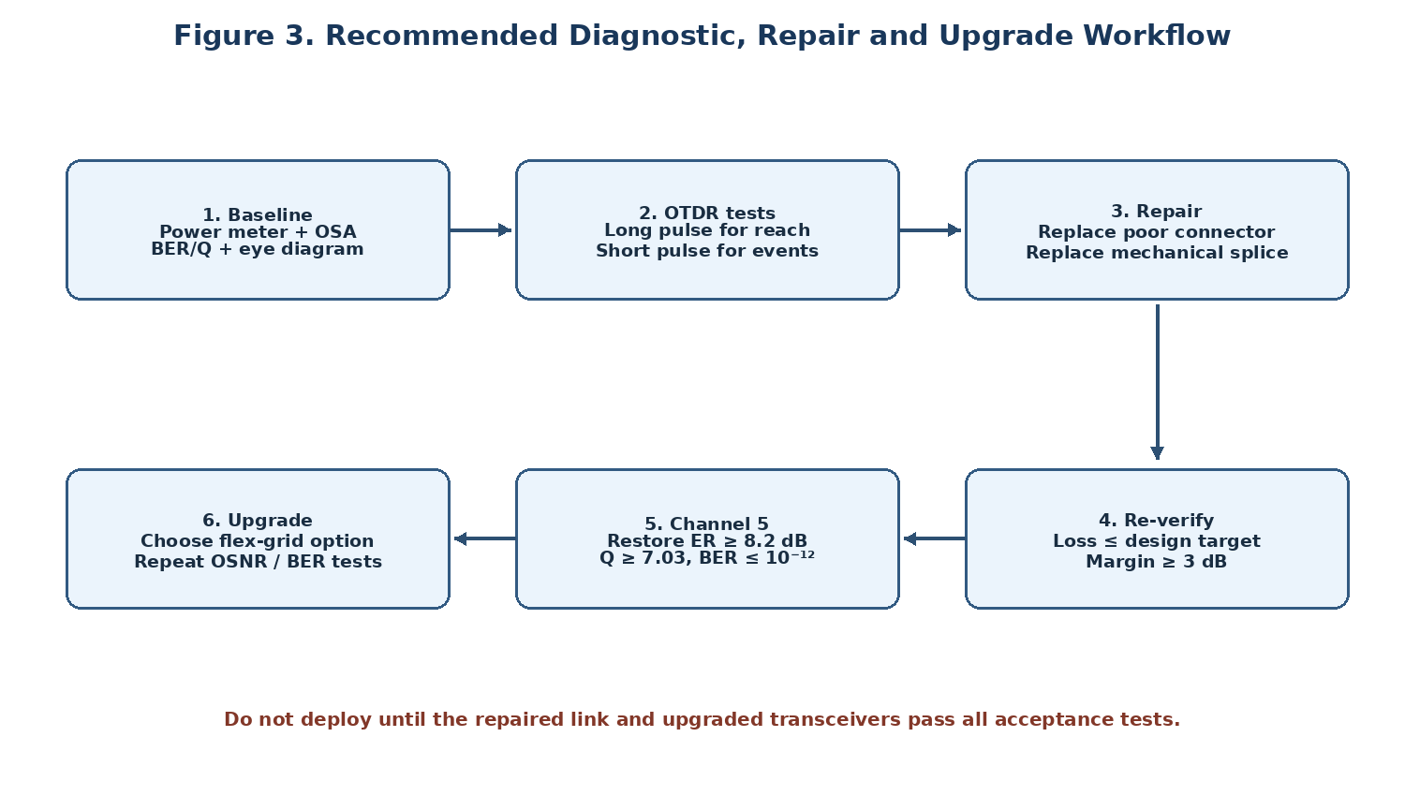
Figure 4. Recommended workflow from baseline measurements through repair, channel verification and upgrade.

Final Engineering Decision
DECISION: YES, WITH CONDITIONS. Do not deploy the current as-built system unchanged: its 22.52 dB total loss exceeds the 21.25 dB design budget, raw received-power margin is only 2.48 dB, and Channel 5 fails the ER, Q and BER criteria. Repair the poor connector and mechanical splice, correct the Channel 5 transmitter/receiver path, and verify the link using bidirectional OTDR, calibrated power-meter loss, OSA OSNR and BER/eye tests. After acceptance, Option Q is the recommended balanced 1.6-Tb/s upgrade candidate. Option R may be selected instead if measured OSNR and FEC results provide sufficient margin and the lowest energy per bit is the overriding objective.

References
- ITU-T Recommendation G.652, Characteristics of a single-mode optical fibre and cable; use the applicable G.652.D specification.
- ITU-T Recommendation G.694.1, Spectral grids for WDM applications: DWDM frequency grid.
- ITU-T optical fiber test and measurement recommendations relevant to OTDR, insertion loss and optical return loss; verify the applicable edition.
- G. P. Agrawal, Fiber-Optic Communication Systems, 4th ed., Wiley, 2010.
- G. P. Agrawal, Nonlinear Fiber Optics, 6th ed., Academic Press, 2019.
- IEC 61280-4-2, Fibre-optic communication subsystem test procedures—installed single-mode fibre optic cable plant attenuation and optical return loss measurement (consult applicable edition).
- Use the actual OTDR, OSA, power-meter and transceiver datasheets for instrument settings, calibration and final commissioning evidence.

